13.97: a) Using the hint,

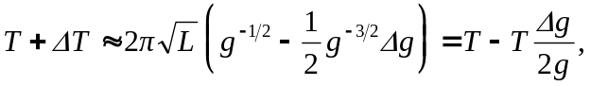

so 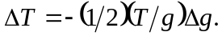 This result can also be obtained from 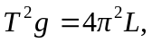 from which

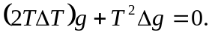 Therefore, 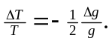 b) The clock runs slow; 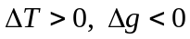 and 